**Lab 05**

**Interfacing Seven Segment Display to 8051 Development kit**

**Objective:**

* To Learn how to use BCD 7-segment display with 8051 micro-controller.

**Components needed for this lab:**

* Keil µVision IDE
* Proteus Software
* 8051 Micro-controller

**8051 Micro-controller:**

* 8051 have 40 pins dedicated for various functions such as I/O, -RD, -WR, address, data, and interrupts.
* The 8051 has an on-chip oscillator but requires an external clock to run it. A quartz crystal oscillator is connected to inputs XTAL1 (pin19) and XTAL2 (pin18). The quartz crystal oscillator also needs two capacitors of 30 pF value.

**TASKS**

**1: Run all the program given in the lecture**

***#include* *<reg51.h>***

**void delay()**

**{**

**int i=0;**

**for(i=0; i<1000000; i++)**

**{**

**}**

**}**

**void main()**

**{**

**P1 = 0x19;**

**delay();**

**}**

C code for showing different number on 7-Seg display

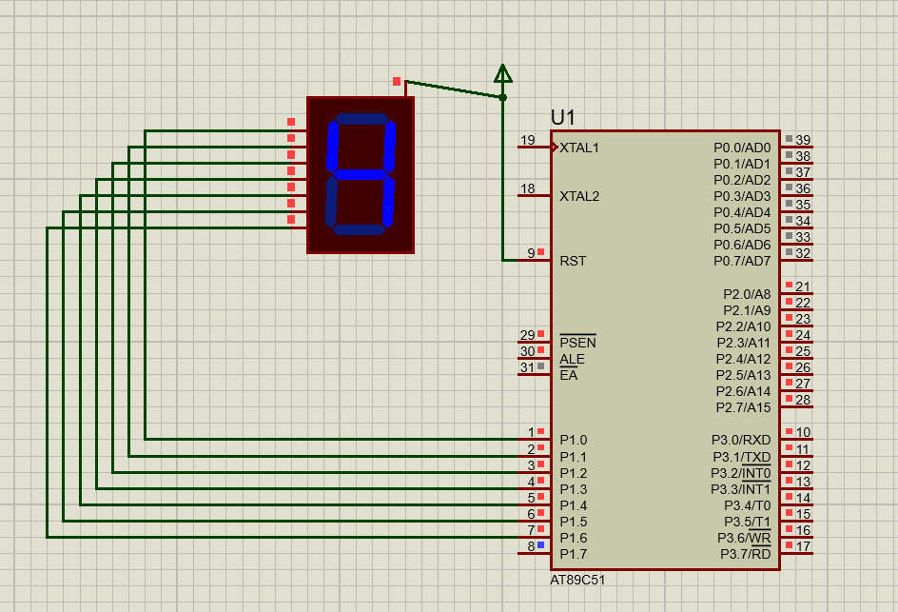

Fig 02: Displaying 4 when input is 0x19h (0001 1001)

____________________________________________________________________________________________

**2: Display different digits on the Seven Segment Display**

***#include* *<reg51.h>***

**void delay()**

**{**

**int i=0;**

**for(i=0; i<1000000; i++)**

**{**

**}**

**}**

**void main()**

**{**

**P1 = 0x40;**

**delay();**

**}**

\

C code for showing different number on 7-Seg display

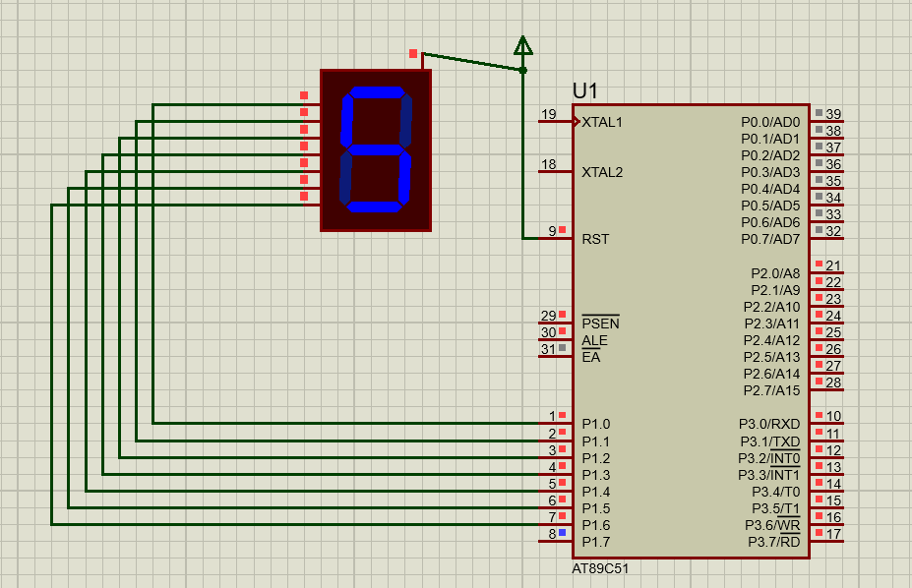

Fig 05: Displaying different numbers

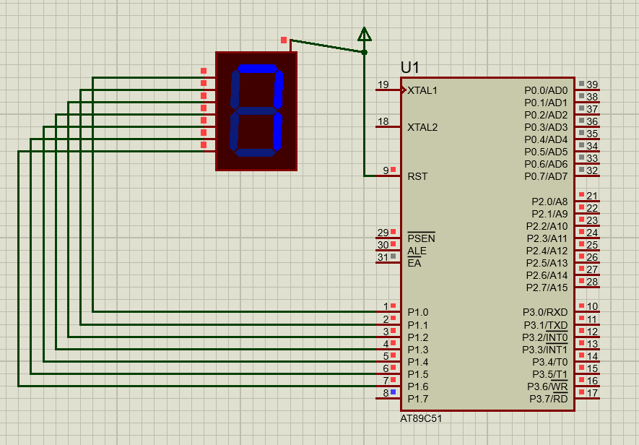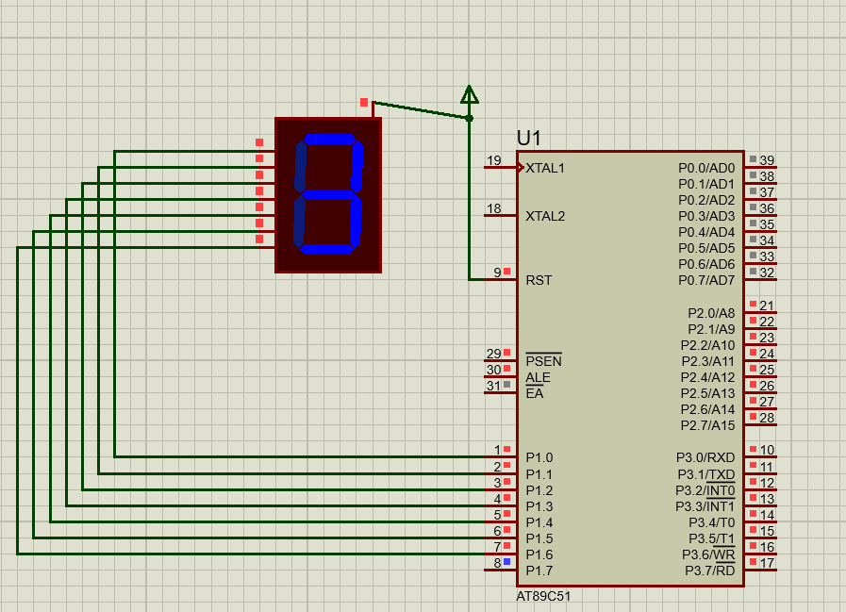

Fig 06 & Fig 07: Displaying different numbers

______________________________________

**3: Display digits from 0 to 9 on Seven Segment Display**

***#include* *<reg51.h>***

**void delay()**

**{**

**int i=0;**

**for(i=0; i<10000; i++)**

**{**

**}**

**}**

**void main()**

**{**

**P1 = 0x40;**

**delay();**

**P1 = 0x79;**

**delay();**

**P1 = 0x24;**

**delay();**

**P1 = 0x30;**

**delay();**

**P1 = 0x19;**

**delay();**

**P1 = 0x12;**

**delay();**

**P1 = 0x02;**

**delay();**

**P1 = 0x78;**

**delay();**

**P1 = 0x00;**

**delay();**

**P1 = 0x10;**

**delay();**

**}**

\

C Code for counting to 9 on BCD Anode 7 – segment display

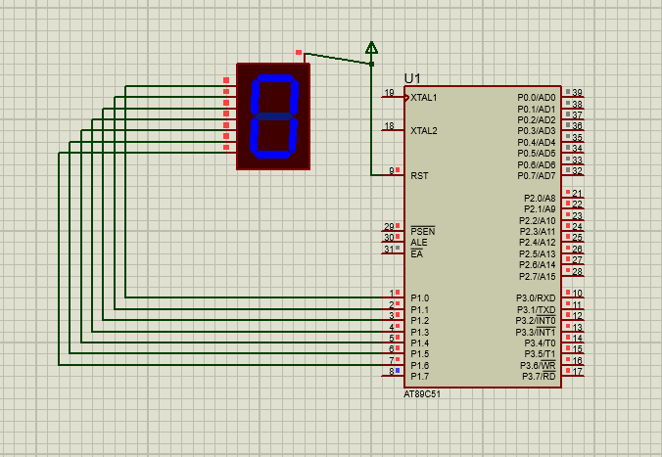

Fig 08: It increments with some milliseconds delay

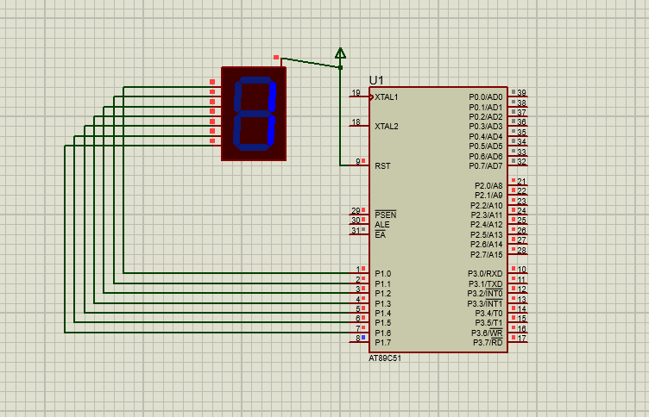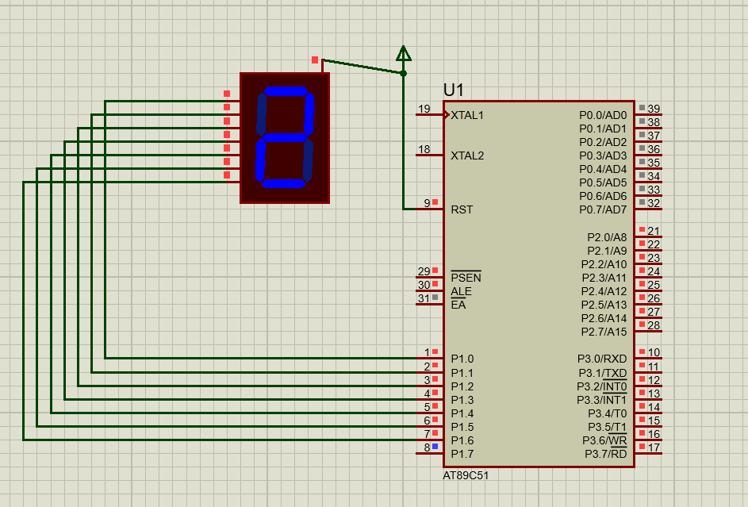

Fig 09: Increments to 1 and then 2

**Conclusion:**

In this Lab we learned about how to show numbers on 7-segment display but here we don’t use BCD to 7-seg decoder instead we just give direct binary sequences to the display.

**____________________________________________________________________________________________________________________________**